Prehistory
Artefacts class timeline

Cut out and use these labels to create a class timeline of prehistoric artefacts. All the images in this resource are of artefacts found in and around London. Ask your pupils to use a map of London to find the places where these artefacts were found.
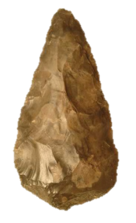

The Palaeolithic period is also known as
the Old Stone Age.
During this time people began to make tools
from stone, bone and wood. This handaxe
was made by one of our earliest human ancestors.
It is made from flint. It was found near
St. Paul’s Cathedral in the City of London.
300,000 BC - 120,000 BC
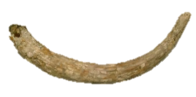
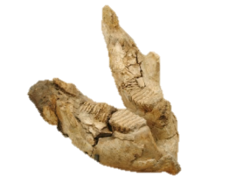
Can you guess who these belonged to?

This tusk and jaw bone belonged to a woolly mammoth around 200,000 years ago.
They were found near Ilford in east London.

200,000 BC - 170,000 BC

The Mesolithic period is also known as the Middle Stone Age. During this time, people moved seasonally to hunt animals and gather food such as berries and nuts.
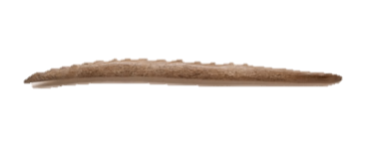
This harpoon is made from antler. It has a spikey, barbed edge and was used to spear large fish or birds. It probably had a wooden handle when it was first made.
What do you think happened to the handle?

It was found in the Thames at Battersea in west London.
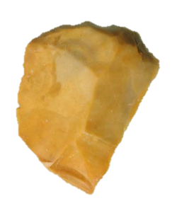
8,800 BC - 4,500 BC
There were lots of different tools in a hunter-gatherer’s toolkit.
Flint was used to make blades, arrowheads and scrapers.
This scraper was found on the Old Kent Road in
south London. It would have been used to prepare
and clean animal skins and furs.
What do you think the skins and furs were used for?
8,500 BC - 6,500 BC
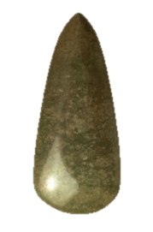
What did people believe?
This finely polished axe is made from jadeite. It is in perfect condition which shows that it was never used. It may have been an offering to a river god. It was found in the Thames at Mortlake.
Jadeite is found in the western Alps, so this axe must have been
brought across to Britain by boat. The beauty of the axe, and the
long distance it travelled, would have made it a very important item
to the local people.
4,000 BC
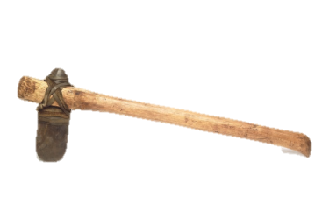

The first farmers
During the Neolithic period, or
New Stone Age, people began
farming. This axe would have
been used for cutting down trees to make space for crops.
4,000 BC
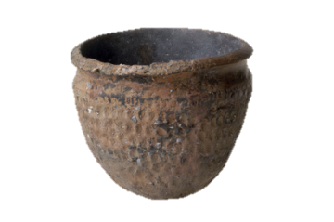
The first pottery was created in the Neolithic period
as people began farming. Clay pots were used for
storing food and cooking. Can you think of
a reason why early hunter-gatherers
did not use clay pots?
This pot was found in Heathrow.
3,500 BC - 2,750 BC
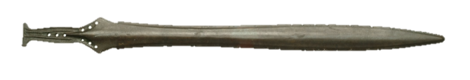

People learn how to make things from metal. They begin to use bronze, an alloy made from copper and tin.
The people who controlled the supply, making and trade of bronze probably became more important and powerful. This sword was found in the River Thames in Richmond.
900 BC

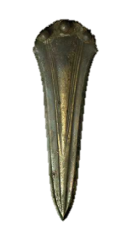

In the Bronze Age, Britain became a fully settled
farming society. People started to live in
roundhouses. The first metal weapons were made
as people wanted to protect their land.
This dagger was found in the River Thames in Bermondsey.
1,700 BC
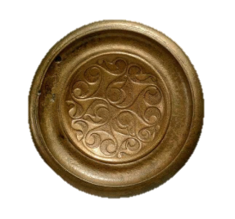
This chariot fitting is decorated with
swirling Iron Age patterns.
Horses were important in the
Iron Age and may have been
a symbol of kingship.
100 BC - AD 43

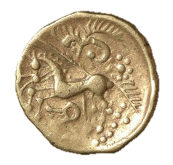
The design on this gold coin shows a horse and a charioteer. It was found on Mitcham Common allotment, south London.

150 BC - 100 BC

