Introducing Roman London study day

Note to teachers:

Print the following activities into booklets for your students to complete in the Roman London Gallery. We suggest that each student has his or her own copy but they could choose to work in small groups, pairs or individually. Students will not have time to complete the whole booklet; we suggest that all students complete the first two pages then choose one of the other three (Setting, Daily Life or Plot). You may want to follow up the activities back in the classroom by asking students to write a story set in Roman London.

Londinium: A tale of Roman London
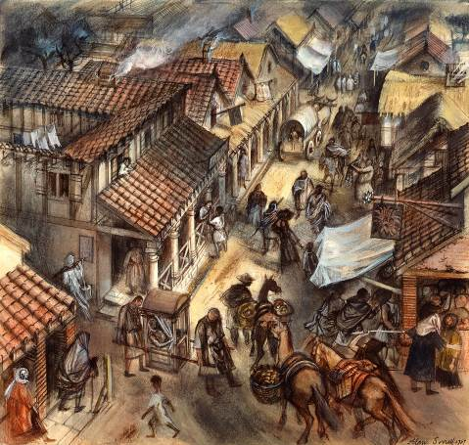

You are a well-known historical writer. You want to set a new novel in Roman London so have come to the Museum of London to research ideas for the main characters, the different settings and the plot. Good luck!

Name:

Pseudonym*:

*Some authors use an invented name, or pseudonym, when they write. What’s yours?

The backdrop
Start by spending a few minutes looking around the gallery. Historical writers have to create an authentic backdrop for the action of their novels. Try to get a feel of what it was like to live in Roman London.
The characters
Who is going to be the main character in your novel? You’ve created a shortlist:
- Gladiator: he is a slave, originally from Palmyra (in modern Syria)
- Wealthy lady: she is a Roman citizen and married to a senior government administrator
- Craft worker: this character is a native Briton, and could be a man, woman or child
- Merchant: he brought his family to live in Londinium from Gaul (modern France)
- Soldier: originally from North Africa, he works as a clerk in the civil service.

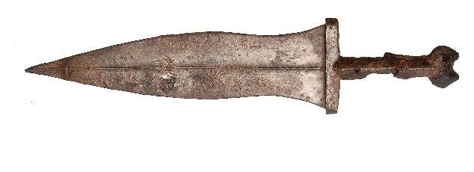
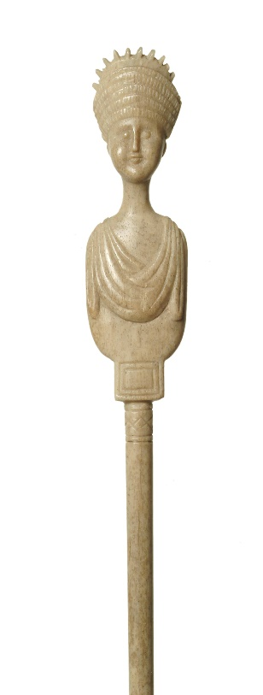
The five objects below can all be found in the gallery and could have belonged to the five characters. Use the words in the box at the bottom of the page to help you label each one. Then match them to an owner by writing the character’s number (in the list above) in the box next to the object that you think belonged to him or her.
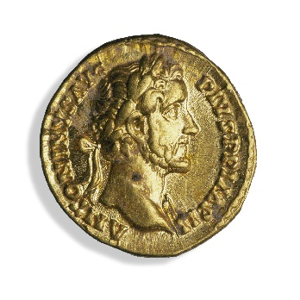

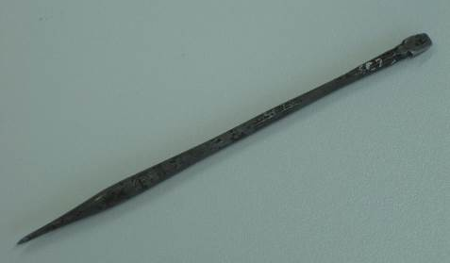

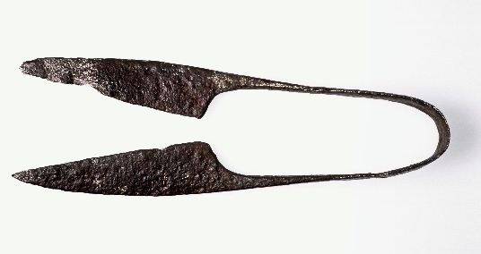

stylus dagger hairpin shears gold coin

The main character
Which of the five characters will be your main character? Underline your choice below. The displays listed will help you find evidence to develop your character.
- Gladiator: The Games people play case, the Public London board and the gladiator video
- Wealthy lady: The reconstructed dining rooms and the dressing table items
- Craft worker: The street reconstruction and the reconstructed living room
- Merchant: The Balance of trade case, the Trading places board and the port model
- Soldier: The Raising standards case and the model of London’s civic centre.
Name:
Hint: Roman women’s names often ended in ‘ia’ and men’s names in ‘us’.
Age:

Physical features, hairstyle and clothing:

Draw a picture or write a description.
Work:

Briefly describe your character’s work or other daily activities.

Draw and label two objects in the gallery that your character uses. These could be related to personal appearance, work or home life.
Draw and label two objects in the gallery that your character uses. These could be related to personal appearance, work or home life.
Draw and label two objects in the gallery that your character uses. These could be related to personal appearance, work or home life.

Setting
(I) Where does your character spend most of his or her day? Use the displays listed on the previous page to help you find out. Make a sketch or write a description of the interior or exterior of your character’s home or workplace.

(II) Use the list at the bottom of the page to label important landmarks in Roman London on the artist’s impression below. Include your character’s home and/or workplace.

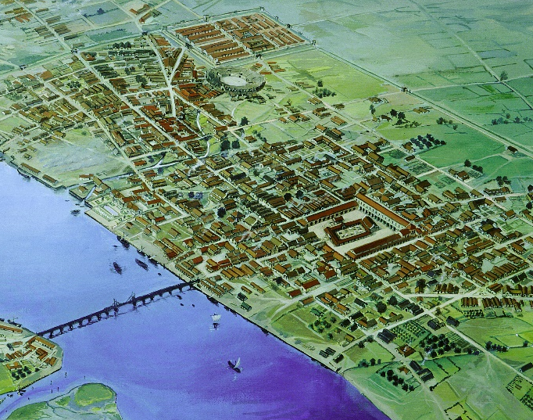

London Bridge fort amphitheatre city wall forum and basilica

Hint: the Public London information boards will help you to identify some of these.

Daily life

Historical writers need to research details of daily life to make their stories convincing. Choose one of the topics below then find the relevant displays and information.

- Food and drink: The kitchen reconstruction and the Food chain information board
- Health and hygiene: The model of the public baths and the In sickness and in health case
- Faith: The Spirituality or superstition? case and the finds from the Temple of Mithras
- Shopping: The street reconstruction and information boards
- Transport: The Going places case and the port model.
(I) List three interesting facts about the topic that your readers may not know.

1.
2.
3.

(II) Create a mind map to show how you could use this topic in your novel eg your character could visit a particular place. Why does he/she go there? Who does he/she meet? What happens?
When?
Where?

?
Why?
Who?

What?

(III) Draw two objects connected to the topic that you could include in your novel. Label them to explain the material(s) they are made out of and how they were used.

Plot
(I) Historical fiction can include elements from other literary genres. Which will you include? Circle one of the genres below:

Mystery Action/Adventure Romance Myth/Legend Crime

(II) Look around the gallery. Choose an object that you could use in your novel linked to this genre then complete the box below. An example has been completed for you.

Main character: Gladiator
Genre: Romance
Object: Leather bikini

Plot link:
The bikini belongs to a young acrobat who the gladiator is in love with.

Plot development:
The young acrobat is also a slave. She is sold to a new master and will be transported to perform in Rome.

Problem/dilemma for main character:
Can the gladiator save her?

Main character:
Genre:
Object:
Plot link:

Plot development:

Problem/dilemma for main character:

(III) How will your story end? Find the Death on the roads out of town case and the Spitalfields Roman. If your main character were to die, what objects would be buried with him/her? Choose three (from these displays or elsewhere) and complete the chart below.

Name/type of object | Use in life | Reason(s) for burial

