Notes for teachers and supporting adults

These activities are designed to help pupils explore museum displays on the British Empire, the abolition of slavery, post-war migration, anti-racist campaigns of the 20th century, and celebrations of cultural identity such as carnival.
These themes will be explored further in your poetry workshop.

Please support your pupils by:

- discussing the timeline to help chronological understanding, and the historical periods spanned by content in the two different galleries
- reading and discussing text panels
- encouraging a sense of empathy and respect for difference
- expanding on the questions within the activity sheets. For instance:
  - Britain’s world links now and in the past
  - what was the British Empire and what is the Commonwealth
  - your pupils’ (and your own) family histories
  - the cultural make-up of their school and local area.

You will be booked to visit the World City and Expanding City galleries on Lower Level 2.
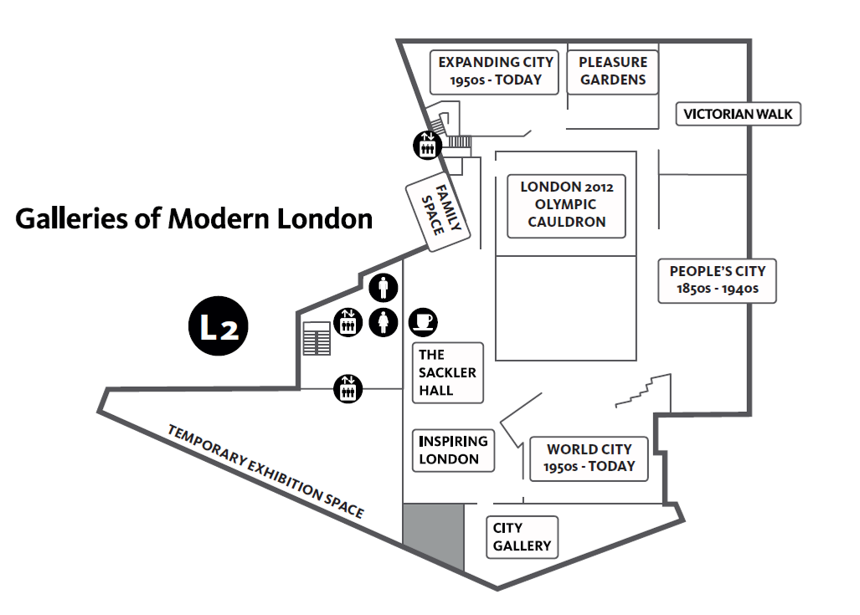
Gallery plans
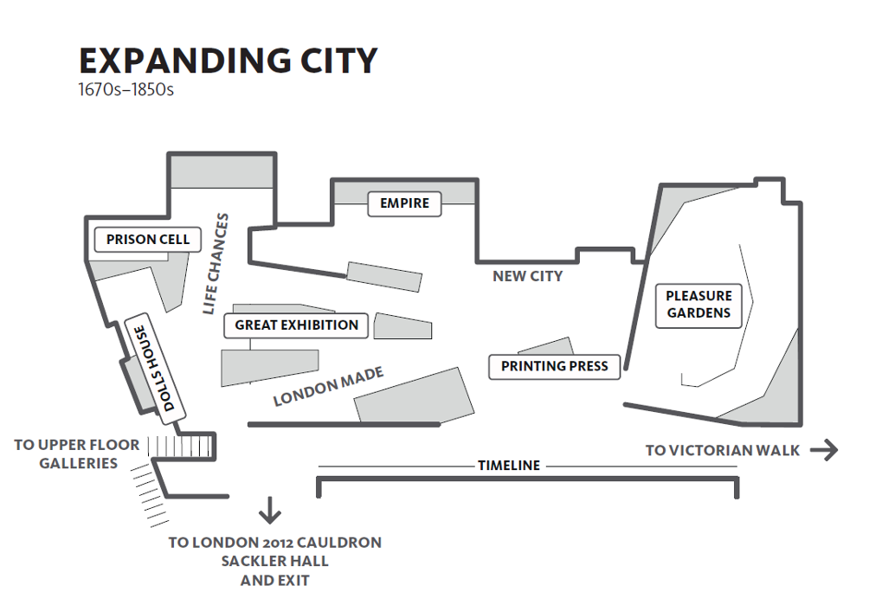
British Empire sliding map

‘The Negroe’s Complaint’ song sheet

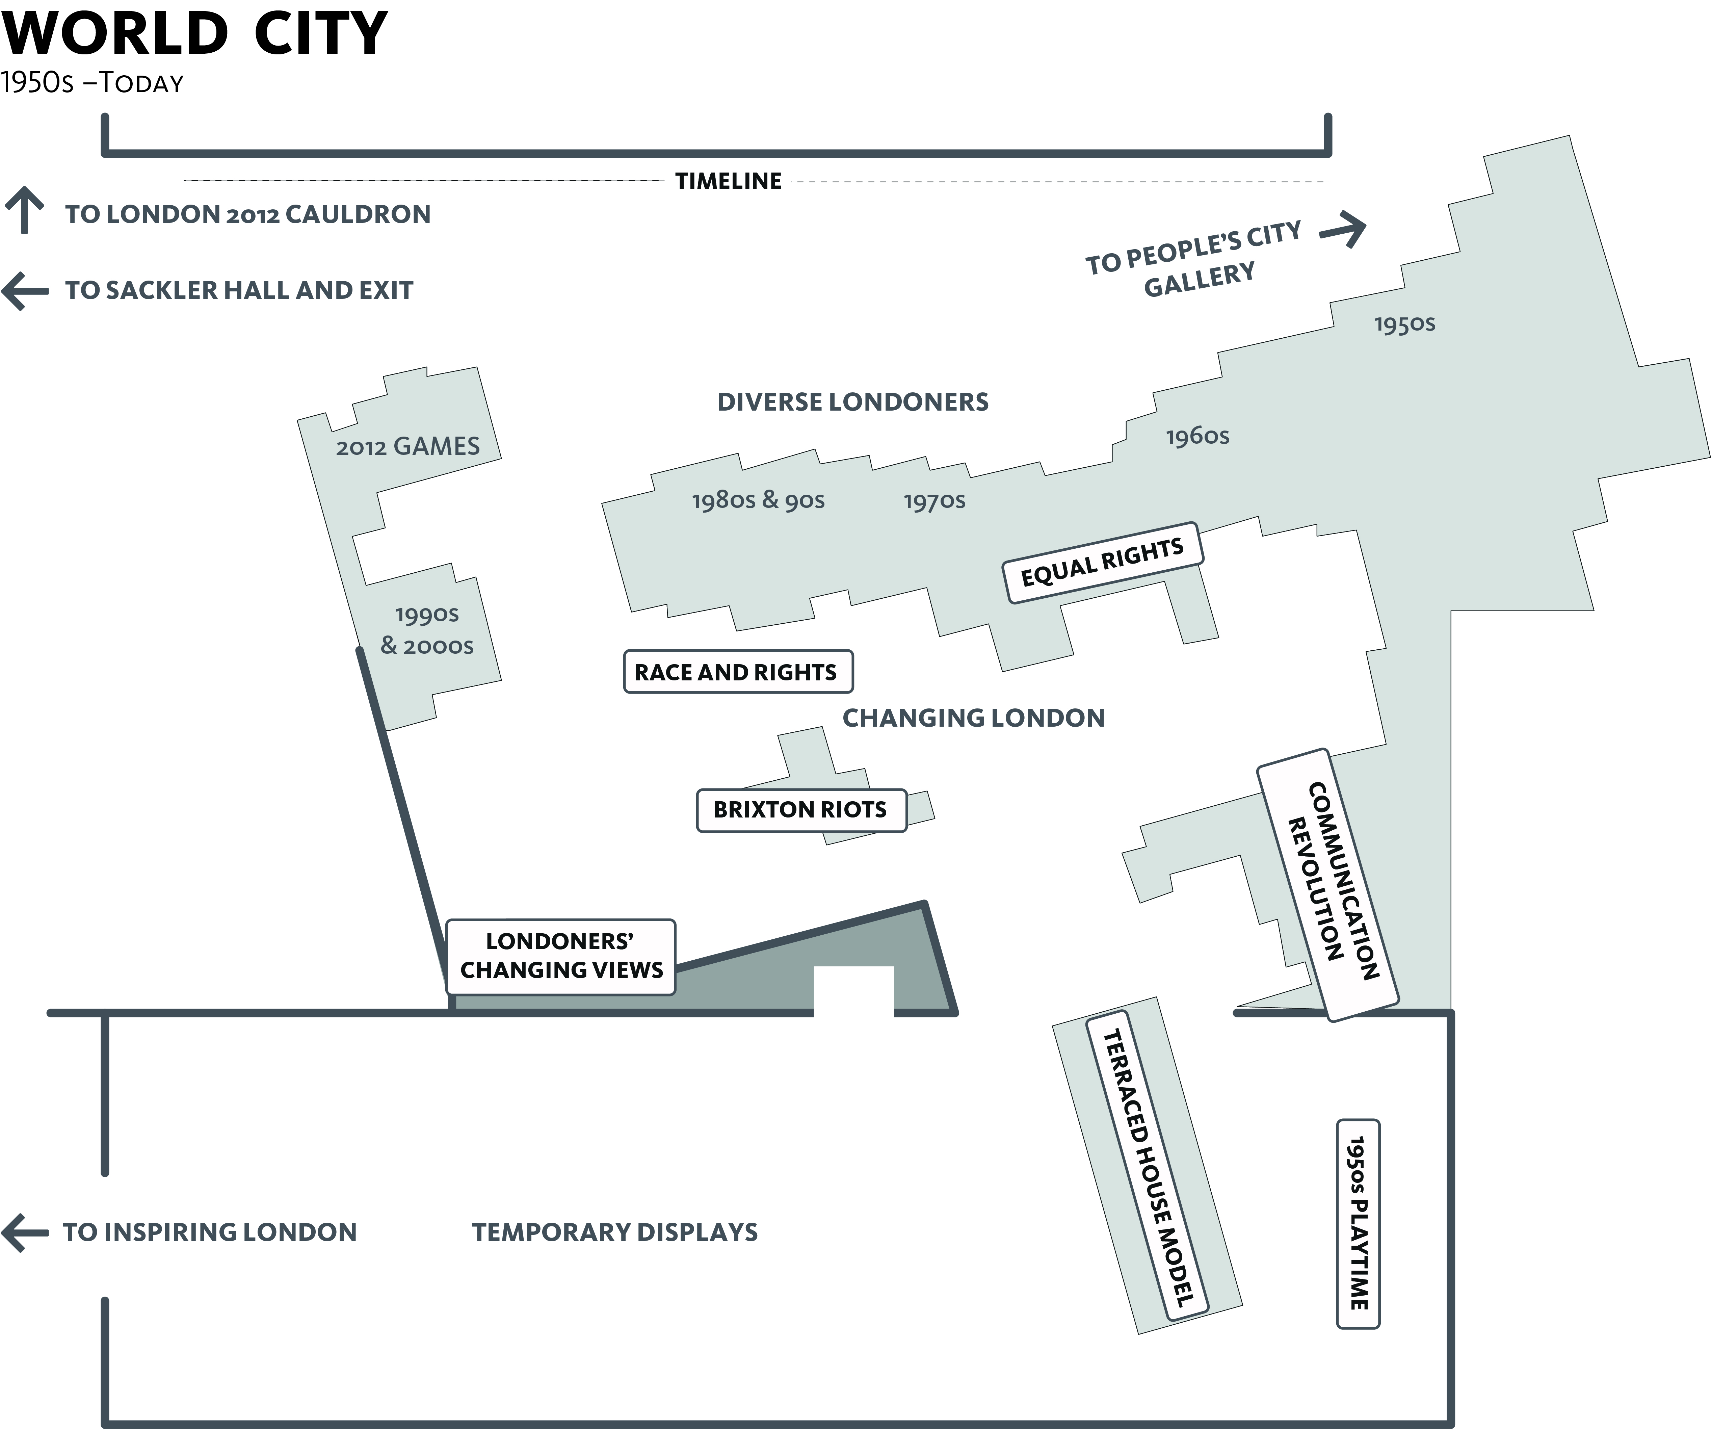
Multi-cultural Londoners
1991 Census
Look at the timeline outside the Expanding City gallery.
Complete the timeline below by adding the two missing dates:
1755 17 __ __ 18 __ __
British rule in India begins.
Olaudah Equiano’s book is published in London as part of the anti-slavery campaign.
Slavery is abolished in the British Empire.

Discuss with an adult: What was the British Empire and the transatlantic slave trade?

The British Empire comprised Britain (the ‘mother country’) and the colonies (countries ruled by Britain). In the 19th century Britain ruled India and much of Africa. The wealth and power of the British Empire was built on the resources traded (or taken) from other countries, including the millions of enslaved African people, who were transported from Africa to work in the British colonies in the Caribbean, and North and South America.

Find the British Empire map slider.

When was the Age of Sail? __________ When was the Age of Steam? __________

Tick when you have smelt the 4 trade products and write where they came from.
Cloves from ………………………….
Coal from ………………………….

Tea from ………………………….

Tobacco from ………………………….

Examine the Age of Sail map. Complete the words of 2 other things traded in London from around the world, and write down where they came from.

Enslaved Africans from AFRICA

SUGAR from ……………………………………….

C O _ _ _ _ from ……………………………………….

T O _ _ _ _ _ from ……………………………………….

Find the floor display with cups of tea on a boat-shaped table.

Discuss: What is this display about? What is the link between tea and sugar enjoyed by rich people in London and the African men and women who worked on the plantations?

Which words and phrases in the floor display suggest a positive view of the British Empire and which suggest a negative view? Add some words of your own to each list.

Positive words and phrases | Negative words and phrases

Find the song ‘The Negroe’s Complaint’ in the Expanding City gallery.
Fill in the missing words:

Men from England ………………….. and sold me,
Discuss: What do you think the last line of this verse means?
Paid my price in paltry ………………….. ;
But, though slave they have enrolled me,
Minds are never to be sold.

Work with a partner to make up another verse or chorus for this song.

………………………………………………………………………………………………………………………………

………………………………………………………………………………………………………………………………

………………………………………………………………………………………………………………………………

………………………………………………………………………………………………………………………………

Look in the Empire case.

You might choose a:
Chinese fan
chest of documents
tobacco shop sign
medals
Mary Seacole’s book

Draw and make notes on some objects related to trade across
the world.

Read the caption for the chart of voyages – How long did it take to travel from London to India in the 1800s?
- 1 week

- 3-4 months
- 1 year

Find the picture of Nowrojee Jamsetjee and his father. What did their company make? Do you think they became wealthy?

…………………………………………………………………………………………..…

…………………………………………………………………………………………..…

Find the globe.
Look at the jigsaw showing a lady representing Europe (Europa) being given gold by Africa. At this time European people divided the world into just four continents. List them below.

- E U R O P E
- A_ _ _ _ _
- A _ _ _
- A_ _ _ _ _ _

Find the paintings Eastward Ho! (1857) and Home Again (1858)
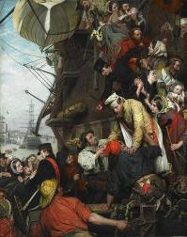
Where were the soldiers going and returning from?

Use the book to find out about the following characters:
- children
- father
- dockworker
- woman.

Now find the 2010 yellow painting EnTWINed.

- Can you find Gandhi?
- Can you find the twins? They are the artists who made this painting.
- Who do you think all the other people are?

Discuss what sort of journeys you think the different people shown in this painting might have made to London.

Choose someone from any of the 3 paintings and write a description of how they might have felt arriving in London.

“ I felt ………………………………………………………………………………………………….

…………………………………………………………………………………………………………

…………………………………………………………………………………………………………

…………………………………………………when I first arrived in London.”
Look the timeline, around the edge of the World City gallery

Find the picture of Kamal Chunchie, above 1928 in the timeline. What organization did he belong to and what did they hope to achieve?

…………………………………………………………………………………………..…
What year did India and Pakistan gain independence from Britain? 19_ _
When was the first commercial passenger jet? 19_ _
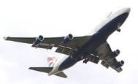
Commercial flights made travel easier, faster and cheaper.
Imagine travelling long distances by boat or keeping up with relatives by letter, before social media and the internet.

Tick the box when you find each of the following on the timeline. Then fill in the blanks to complete the song, poem and quote:

Lord Kitchener’s calypso song.

“London is _ _ _ p _ _ _ _ for _ _ ! ”

Benjamin Zephaniah’s poem

“I love this g _ _ _ _ p _ _ _ _ e d place,

Where pop stars come to l _ _ _ t _ _ _ _ d_ _ _ _ s…”

Nelson Mandela’s quote about London hosting the Olympics.

“There is no city like London, It is a wonderfully d _ _ _ _ _ _ and o _ _ _ city.”

Write your description of London and how it makes you feel.

………………………………………………………………………………………………………

………………………………………………………………………………………………………

………………………………………………………………………………………………………
Find two photographs of Portobello Road in the 1960s.

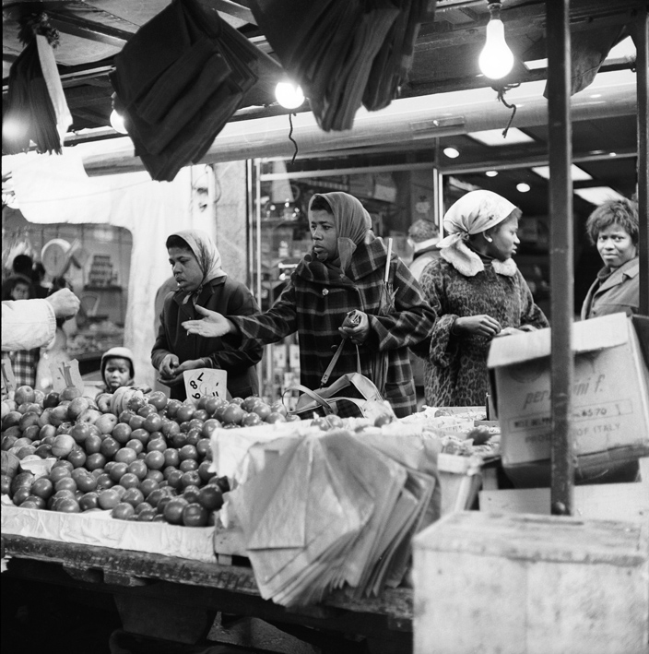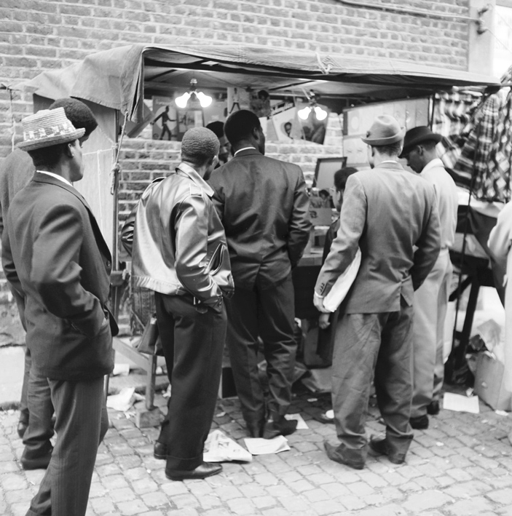
London became more culturally diverse as migrants were encouraged to take British citizenship and come to London for work, yet they often faced racist attitudes.

Discuss how you think these people might have felt about life in London? Write some positive and some negative things about their experiences of migration.

Positive | Negative

Fill in the missing letters
After the Second World War many countries that had been a part of the British Empire became independent, but kept links with Britain as part of the C_ mmon_ _ _ _ th.

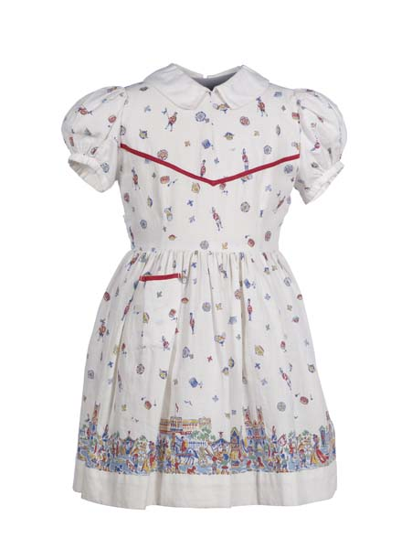
Find the 1953 dress

At what celebratory occasion was this dress worn?

……………………………………………………………………………….

Discuss national celebrations, such as the Festival of Britain (1951), the coronation of Queen Elizabeth II (1953) and the Olympic Games (held in London in 1948 and 2012). Were new migrants to London in the 1950s likely to feel proud of their British identity?

Find the costumes worn at the opening ceremony for the 2012 Olympic Games. Do they represent and celebrate how multi-cultural Britain is today?

Find the Global Londoners display next to the 1960s case.

Whose suitcase is on the Heathrow luggage trolley and why did he cry on it?

…………………………………………………………………………………………..…

In the 1960s many refugees came from Uganda. A refugee is someone who moves because their lives are in danger in their own country. Discuss and write down some reasons why people emigrate (move to another country).

…………………………………………………………………………………………..…

…………………………………………………………………………………………..…

Draw some of your favourite outfits from the 1950s – today. Discuss what these clothes say about the time they were made and the identity of the people who wore them, or the occasion they were worn at. Discuss whether some of these clothes are specific to particular cultures or faith groups.

Find the multi-cultural Londoners display.

The different communities we belong to are part of who we are. The first census to ask people to classify their ethnicity was in 1991.

How many ethnic groups were classified in the 1991 census?
How many ethnic groups were being classified 10 years later in 2001?
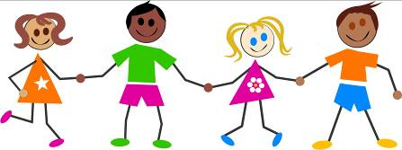
How would you classify yourself and your friends at school?
Draw a picture of yourself and list the ethnic groups, religions and languages spoken by you and your friends.

I am…
Ethnic groups at my school include:

Religions practiced by people at my school include:

Languages spoken at my school include:

Find the Race & Rights/ Race & Riots displays

Find the badges worn by people to campaign against racism. Copy two of the badges and then design your own.

