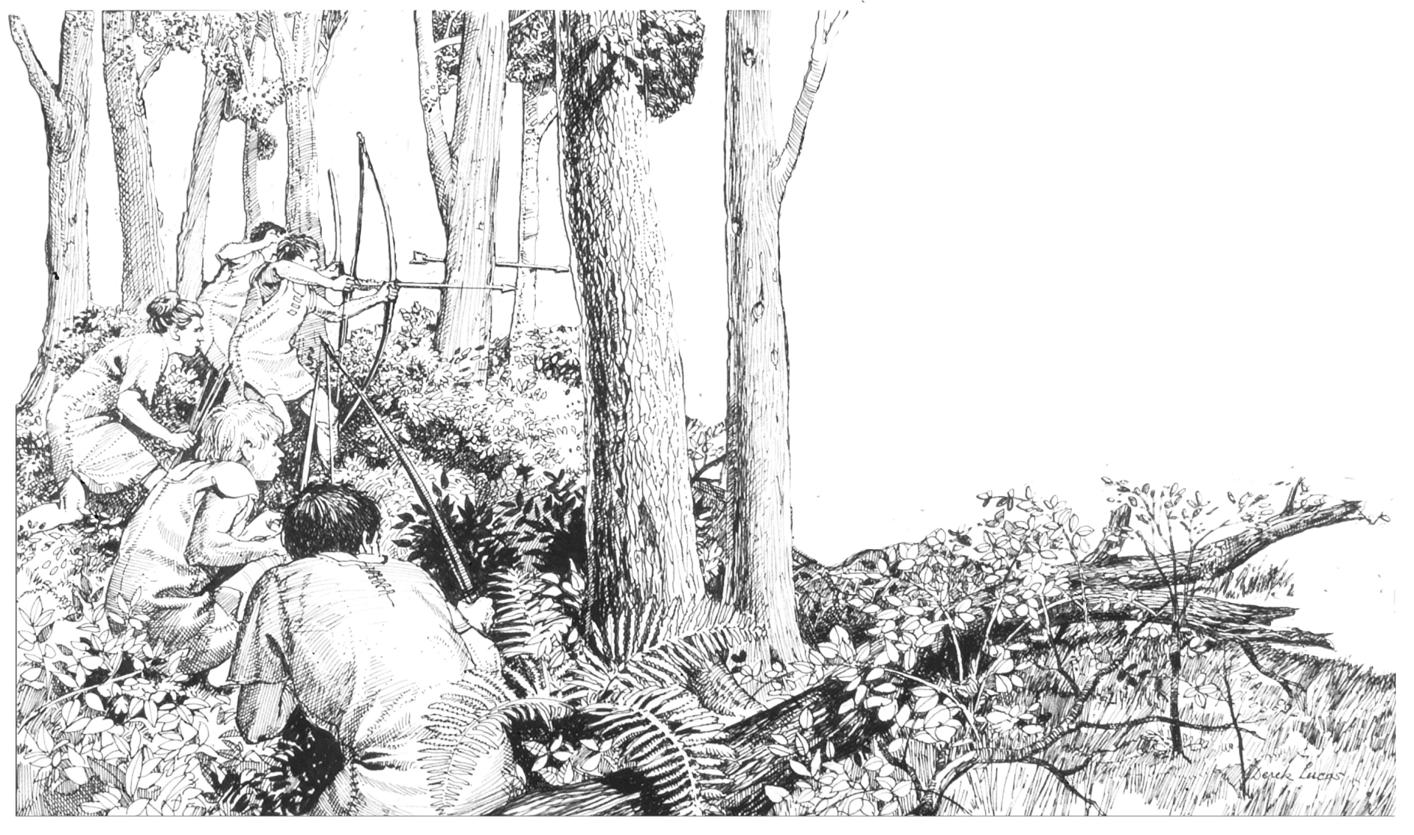

Stone Age
storytelling

This booklet contains short stories, poems and ideas to support your teaching of prehistory through literacy and storytelling.

Background information
Prehistory describes the time before written records. In Britain, this is the time before the Roman invasion in AD 43.
Without written evidence we look to archaeology to tell the story of prehistoric Britain. We examine artefacts, remains and landscapes to imagine what life may have been like.
Almost half a million years before the city of London was founded, our early ancestors walked across a land bridge from mainland Europe into what would become the British Isles. The Thames Valley provided hunting grounds for Stone Age hunter-gatherers tracking herds of animals. Then later, in the Neolithic, Bronze Age and Iron Age, the valley provided homesteads and farmland to the families and communities who settled there.
From the first people with their instinctive understanding of the landscape and the natural world, to the sophisticated tribes of Iron Age society, people would probably have drawn on a rich tradition of oral storytelling and beliefs.

museumoflondon.org.uk/schools
The fire child
During the Mesolithic period (Middle Stone Age) the climate warmed causing the landscape to change from tundra to woodland. Hunter-gatherer groups moved in and out of Britain via a land bridge until we became permanently cut off from Europe around 6500 BC.
Use this first person short story to help pupils imagine what it may have been like to be a child in a Mesolithic hunter’s camp.

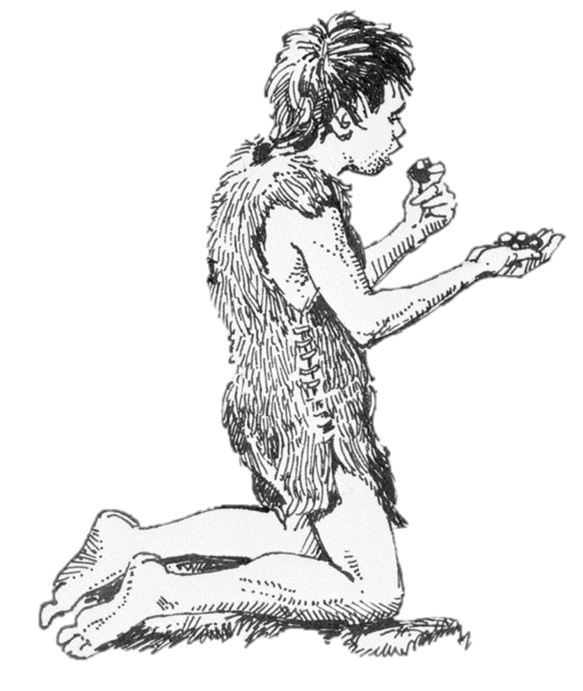
I like the darkness – it wraps me warm in its embrace. Glowing embers dance in the air above the fire; I hear the distant howl of dogs in the valley. My stomach growls, I’m hungry. We have been travelling for days eating the roots, berries and nuts we gather. The fish we ate as we moved north seem like a memory.
I hear the murmur of the elders circled around the fire, preparing their weapons for tomorrow’s hunt. Their stories drift over me, tales of generations who have visited this camp. Slowly I creep out from my furs and crawl towards the fire to listen to them. Chip, chip, chip, skilfully and quickly they work the flint. Discarded flakes scatter to the ground around them.
The elders laugh as one of the younger hunters exaggerates his hunting stories – father looks up smiling but a distracted knock with the antler hammer fractures the flint he is working. He throws the fragments into the fire and without a breath picks out the next core from the reindeer skin bag by his feet.
The smell of the smoke and the murmur of the stories pull me back to sleep. I am lifted from the circle and carried back to the furs where my baby brother is snoring quietly.

Background information
During the Mesolithic period, people began to manage the forest by creating clearings to lure prey such as red deer and wild boar. At Three Ways Wharf in Uxbridge, archaeologists discovered the remains of a hunter-gatherers’ camp. They meticulously recorded the position of every scrap of flint and animal bone they unearthed. This evidence suggests that a community of up to 20 people would have gathered around a hearth making tools and working animal hides. People would probably have drawn on a rich tradition of oral storytelling and beliefs about hunting magic.
Why not try making a pretend camp fire to sit around for storytelling?
Hunter-gatherer groups would have had a natural understanding of their environment, the weather and the night sky. Take the children on a senses nature walk to listen, smell, feel and look at the natural environment. Using the fire child story as a stimulus, create a word bank of sights, smells and sounds that the fire child would have heard on his or her journey.
Ask pupils to:
- describe the smells and sounds in the forest on a rainy day or sunny day
- think of words to describe the sound of people’s feet stalking through the forest
- talk about what emotions they might feel if they were allowed to join a hunt for the first time
- talk about how it might feel to go hungry if food was scarce or the hunt failed
- describe the feeling of having a full belly after a successful hunt.
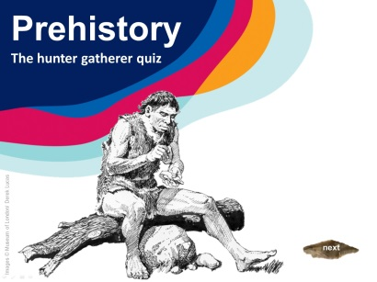
Download and play the ‘Hunter-gatherer quiz’ to find out if your pupils have what it takes to survive life in the Stone Age.

Gifts to the water
The jade that this axe head (pictured) is made from, originates in the Alps. It would have been an extremely precious and valuable object. The axe, along with hundreds of artefacts from throughout the prehistoric period, was discovered in the Thames. But why would someone deposit an item of value in the water? This short story uses an object as its focus and asks pupils to imagine the emotions and motivations of the people it comes into contact with on its long journey from the Alps to the Thames.
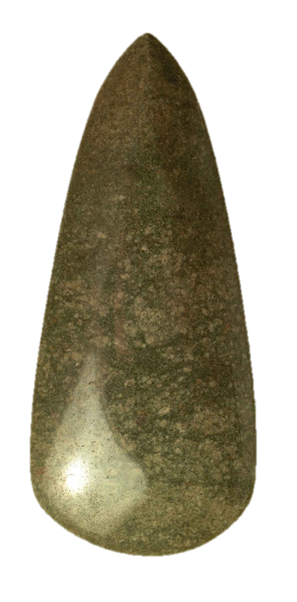
Our journey starts far, far away in the mountains of a distant land. A craftsman holds, in his rough hands, a beautiful piece of green jade stone. He turns the stone over and over, feeling the material, deciding where to make his first strike. He sets to work. Skilfully he chips away at the stone, slowly revealing the rough form of an axe. He works quickly to create the shape, knowing that the long task is ahead of him. He smiles and sighs heavily as he puts the axe away until the next sun.
One hour a day for a hundred days,
one hour a day for a hundred days.
The craftsman is concentrating now, patiently polishing the stone. Day after day, he returns to his work carefully rubbing the surface of the axe until it gleams in the evening sunlight. He is finished. He runs his hand over the cool, smooth surface, checking for imperfections, feeling its weight, ‘This will trade well’ he thinks.
Before the next new moon, the axe is indeed exchanged for a handsome sum of animals and goods. The craftsman, contented, watches as the axe is packed into a bag to begin its journey over land and sea to a far off place.
And here it is now, in the hands of my mother. My father stands beside her on the edge of the wooden platform out into the river. My mother’s face is streaked with tears as she stretches out her arm and lets the axe slip from her hands into the depths of the water. The waves roll gently on the foreshore as the singing begins.
Come every son, come every daughter
We offer our treasures to the mighty water.

Background information
London’s longest ‘archaeological site’, the River Thames, clearly played a vital role in the lives of people throughout prehistory. Thousands of artefacts have been recovered from the river and its banks, enabling us to piece together a picture of how life changed over time. Finely polished stone axe heads, elaborate shields and ornate swords, were all deposited in the river unused. Archaeologists have even found the remains of a wooden platform, on the river bank at Vauxhall, perhaps enabling people to walk further out into the water to leave their gifts.

Ask pupils to:
- describe how it might feel to do the same task for a hundred hours
- suggest reasons why someone might offer something so precious and expensive to the water
Were they thankful, asking for help or some other reason?
- talk about what emotions a person might be feeling as they give their offering to the water
Do you think the mother in the story was crying tears of happiness or sadness?
- picture or act out the scene at the water’s edge. Was it quiet, as a person privately left their gift? Or was there ceremony, singing and crowds gathering?
- imagine they are giving an offering to the river. What would it be? Why?

Journey through the Stone Age

Imagine going back in time,
then back a little more,
when people gathered forest fruits
and hunters caught wild boar.

You’re entering the Stone Age now
but which part will it be?
How about the Palaeolithic,
when mammoths roamed quite free?

This time is marked by artistry
and paintings deep in caves
of sorcerers and animals
to make the hunters brave.

Perhaps you stalk through woodland,
hunting in the Mesolithic?
Bow and arrow in your hand
You’re feeling quite terrific.

You learn your skills from elders
who teach you to catch deer.
Then back to camp for feasting
full bellies, raise a cheer.

Now people’s lives start changing,
new ideas come into play,
of farming, crops and pottery
leading life a different way.

The Neolithic farmers
work so hard to tend their land
they’re looking to the solstice
when a rest will be at hand.

Now our Stone Age journeys finishing
there’s no need for feeling glum
prehistory doesn’t finish there
The Bronze age is still to come!

Background information
The Stone Age is divided into three periods. Palaeolithic meaning Old Stone Age, Mesolithic meaning Middle Stone Age and Neolithic meaning New Stone Age.

Ask pupils to choose a period in the Stone Age to write their own Stone Age poetry.
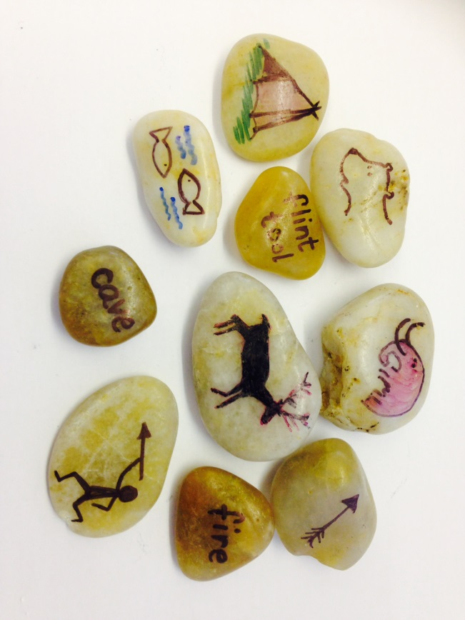
Story stones

Create a class set of Stone Age story stones showing animals, objects, actions
and places.

Ask pupils to:
- choose a stone from each category to use in the own story or poem
- choose one stone for a story starter, one for the middle and one for the conclusion
- place all the story stones in a bag. Working in a small group the first
pupil takes a story stone from the bag to begin the story. When they
have finished, they pass the bag onto the next pupil who takes a
stone and continues the story using the object or place represented on their story stone.

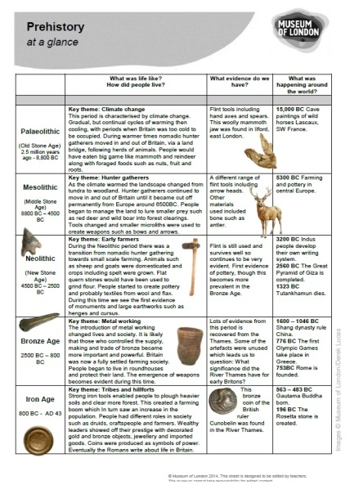
Find out more about each period by downloading ‘Prehistory at a glance’.
http://www.museumoflondon.org.uk/schools/classroom-homework-resources/prehistoric-london-resources/

Images © MuseumofLondon/Derek Lucas
Stories and poetry ©MuseumofLondon/Claire Bogue
© Museum of London 2014. This sheet is designed to be edited by teachers.
The museum cannot take responsibility for edited content.

