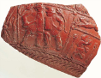
Amphitheatre activity sheet
Archaeologists have only uncovered part of London’s Roman Amphitheatre, but enough remains to estimate it’s size in Roman times.

What the walls are made from? _________________________________________

What the drains are made from? ________________________________________

Try to imagine the amphitheatre around you. Much of the structure no longer exists and originally the walls would have been much higher, can you work out which part of the amphitheatre you are standing in?

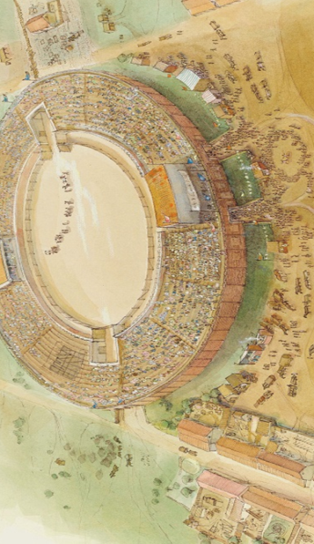
Draw a line around the area of archaeological remains that you are standing in on the picture above.

Tick when you have found the following features:

Boxes (Covered areas from where important Romans would watch)

Entrances (Two entrances for Gladiators and two smaller entrances for spectators)

Gladiators (A line of gladiators have just entered the arena.)

Market stalls (Selling food and souvenirs, just like at modern sports stadiums)

Seats (All of the seats were made from wood.)

How many people could London’s Roman Amphitheatre could hold?
(Read information panels for the answer)

Amphitheatre activity sheet
What was Roman London called? L _ N _ _ N _ _ _

Why do you think the city was built here? What was it about it’s geographical location that meant it became important to Roman Britain?

___________________________________________________________________

The settlement quickly grew into an important city with streets laid out in a grid pattern and many impressive buildings. The picture below shows how Londinium may have looked almost two thousand years ago.
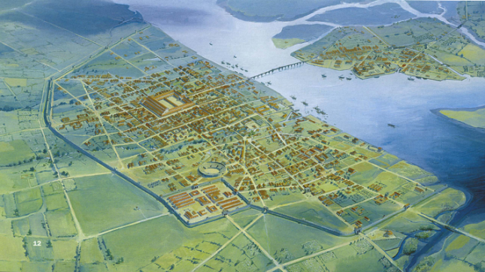

Tick when you have found each of the following:

Amphitheatre (A large oval arena similar to a football stadium.)

Bridge (Built at the end of the tidal reach of the Thames, and important to the nextwork of roads leading from the city.)

City walls (built to protect the city, the walls stretched for over two miles)

Forum (A Roman market. The open space surrounded by buildings,at the centre of the city)

Port (Ships from around the Roman world docked along the Thames)

Fort (A retangular enclosure of numerous buildings, used by the army).
Amphitheatre activity sheet
Imagine if you could go back 2000 years, who would be standing where you are today? Who went to the amphitheatre and why? Draw 3 characters and write about their day at the Amphitheatre. (One example has been given).
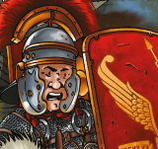 | I am a soldier. I live in the fort nearby.  Today we impressed the people of Londinium with a display of the skills of the Roman army. We marched around the amphitheatre arena for hours. I’m exhausted!

Amphitheatre activity sheet
Ask you teacher if you can role-play a short drama about visiting the amphitheatre. (Some replica clothes maybe available to help you).
Did you know that men and women did not sit together? Important men sat at the front, less important men sat behind them, and women sat right at the back!

Decide if you are a:
- a rich Roman Lady or her daughter
- a wealthy Roman merchant or his son
- a poor slave
- someone selling food or souvenirs
- a soldier, acrobat or gladiator, performing in the arena

Decide what event you have come to watch. Gladiatorial games and wild animal hunts were rare exciting events, other events such as army drills may have happened more regularly in the arena.

Alternatively you might like to draw a picture of people at the amphitheatre, you could add speech bubbles if you like.

