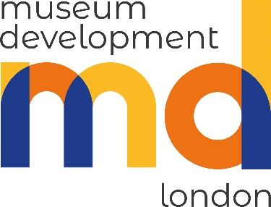

Fund the Future: Income Generation Programme 2022
Application Form

Closing date for applications: by 5.00 pm on Monday 18 July 2022

to mdgrants@museumoflondon.org.uk
Please note applications submitted after this deadline will not be accepted.
It is essential that you read the Guidelines for Applicants before filling in this form. Please read the application form carefully and fill in all sections of the form as fully as you can. Please put the name of the programme you are applying for into the subject header of your message to the email address above.
1. Your organisation
Name of Organisation:
Address of Organisation:
Contact name:
Job Title:
Contact email address:
Contact telephone number:
Is your museum within the City of London & 32 London Boroughs? | Yes | No | Which London Borough are you based in?
 | □ | □
Is your museum fully accredited? | Yes | No | Accreditation Number:
 | □ | □
Is your museum officially ‘Working Towards Accreditation’? | Yes | No | Temporary Accreditation Number:
 | □ | □

2. Information to help us assess your application
Current opening hours
What do you see as the key income generation challenges for your museum during the current financial year to April ’23 and up to April ’25.
Please give a summary of your museum’s current income generation activities.
Does your Forward Plan or any other strategy documents (such as a fundraising plan) include priorities for income generation? |  | Yes  ☐ | No  ☐
Please describe existing objectives as described in your forward plan

4. Museum’s Financial summary
Total museum income in the last year before the pandemic (2019/20)
Comments:
Total income in the last financial year (2021/22)
Comments:
Total anticipated income for this year (2022/23)
Comments:

5. Information provided in support of application
Forward Plan | Evidence provided as an attachment to the application form: | Yes  □ | No  □
 | Please submit a copy of the museum’s current Forward Plan along with the application.
Other strategic documents | Please submit any other relevant documents (list titles)

6. Skill Sharing
Please indicate how you intend to share learning from involvement in the scheme with the wider museum community:
a. Participate in skills sharing events e.g. training as required: | Yes | No | Any comments:
 | □ | □
b. Write a case study for the Museum Development Team and Arts Council England: | Yes | No | Any comments:
 | □ | □
c. Other | Yes | No | Evidence provided:
 | □ | □ | If other, please describe:

7. Submitting your application
a. Application Declaration
The following declaration must be signed by the senior officer responsible for this project:
I declare that the information given above is correct to the best of my knowledge. I understand that Museum of London’s standard grant conditions will be applied. I give permission for the Museum of London to retain my organisation’s Forward Plan on file for uses as stated below.

Name (please print):
Job Title:
Signature:
Date:
b. Please attach your current Forward Plan alongside this application.
Our policy regarding use of information:
All information provided in this application will be used only for the purposes of awarding these grants. Any contact information provided will only be used in reference to your grant application or project.

Applicants Forward Plans will be retained, in confidence, to help us to support you with future training, advice and programmes.

