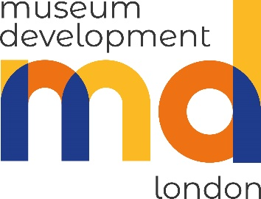

Museum Development London

Planning successful fundraising events for museums

Date: Friday 22 March 2024
Time: 10.00 am – 12.30 pm
Location: ONLINE on Zoom
Facilitators/Trainers: Consultant David Burgess of Apollo Fundraising, worked with 8 London Museums over the last 2 years through our Fund the Future programme to create a bespoke action plans. David combines considerable experience and his learning from these recent consultancies to provide training for the London Museums sector.

What will be covered?
The session will go through a structured approach to developing income-generating events.
The session will focus on the 3 key parts of the process, providing delegates with tools & processes to consider the types of events that are right for their specific situation. Includes:
- A model for taking a more structured approach to idea generation, helping participants understand from an early stage which ideas are worth exploring further
- Identifying potential audiences & their needs to ensure there is a market for the idea
- Considering how to price your event to ensure it is both competitive & profit-making
- Going through 10 factors to consider when assessing the feasibility of your idea
- Top tips for turning your chosen idea into a reality, including how best to market your idea and how to keep developing it after the pilot event.

Who should attend?
This course is aimed at staff, paid or voluntary, who are engaged in fundraising and programming of fundraising events for their museums to provide them with skills and advice for understanding how best to develop a successful fundraising events programme.

Approximate session timetable:
10:00 Log on and Session 1
11:15 Break
11:30 Session 2
12:30 Close

Learning Objectives:
By the end of this course you will:
- Understand how to focus ideas generation to improve both the quality and quantity of initial ideas
- Be able to identify which ideas are worth being considered for further development
- Understand how to assess the initial feasibility of an event against the museum’s key goals
- Have a checklist of things to consider when developing an idea to minimise risks and challenges
- Top tips for implementing the event and developing it further.

Support towards Museum Accreditation:
The session(s) will help you to meet the following Accreditation requirements:
2.1 Approved forward or business plan which covers the current and subsequent planning year
2.2 Financial sustainability

Instructions:
1. Please ensure you have your line manager’s permission to attend before booking your place as confirmation is sent to the museum.
2. Final confirmation of places will be sent out two weeks before the date of the course. Please keep the date available in your diary until your place has been confirmed.
3. Priority is given to staff and volunteers working in non-National and non-National Portfolio museums in the London region.
4. Refreshments and lunch will be provided. Please specify on your application if you have any dietary requirements.

Keep in touch with MD London:
Follow us on X: @LondonMusDev
Sign up on this link to our regular e-update Newsletter for up-to-date news on funding, conferences, training events, jobs and a digest of sector news.

