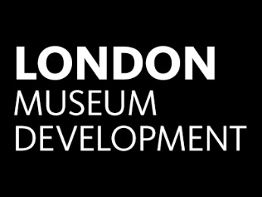
London Museum Development

Diversity Matters Programme

2018-2022

Case Study Form

Closing date for case studies: 5.00pm on Monday 16 July 2018.

Many thanks in advance for your willingness to provide a case study to the London Museum Development (LMD) Team.

If you have any queries about the Case Study Form, please contact Rachael Crofts, Museum Development Officer Audiences: rcrofts@museumoflondon.org.uk.

1. Basic details on your organisation
Name of Organisation:
Address of Organisation:
Contact name:
Job Title:
Contact email address:
Contact telephone number:

2. Basic Information on your Project:
Title of project:
Project start date:
Project end date:
How much did your project cost?
Did you receive external funding | Yes  □ | No  □ | If yes, please provide the name of the funder:
Which of the 4 key areas of diversity practice does your project focus on? | Diversifying your public programmes/events, exhibitions and collections to be more representative of under-represented groups: |  |  | Yes  □ | No  □
 | Diversifying your audiences through targeted programming to be more representative of under-representative groups: |  |  | Yes  □ | No  □
 | Diversifying your board of trustees to be more representative of under-representative groups: |  |  | Yes  □ | No  □
 | Diversifying your paid or volunteer workforce to be more representative of under-represented groups: |  |  | Yes  □ | No  □
Which protected characteristic group(s) did you target / work with during your project? | Age: |  |  | Yes  □ | No  □
 | Disability: |  |  | Yes  □ | No  □
 | Gender reassignment: |  |  | Yes  □ | No  □
 | Marriage and civil partnership: |  |  | Yes  □ | No  □
 | Pregnancy and maternity: |  |  | Yes  □ | No  □
 | Race: |  |  | Yes  □ | No  □
 | Religion and belief: |  |  | Yes  □ | No  □
 | Sex: |  |  | Yes  □ | No  □
 | Sexual orientation: |  |  | Yes  □ | No  □
 | Class and socio-economic status: |  |  | Yes  □ | No  □

3. Further information on your Project
a. Please describe your project’s aims (up to 200 words):
Questions to consider: What were the aims of your project?
b. Please describe the group(s) you worked with (up to 300 words):
Questions to consider: Who did you work with? How did you recruit your group(s)? Why did you work with this group(s)?
c. Please describe what you did as part of the project (up to 300 words):
Questions to consider: What did you do? How often did you meet the group(s)? How were the group(s) involved throughout your project?
d. Please describe what you achieved as part of the project (up to 300 words):
Questions to consider: What were the outputs and outcomes of the project?

4. Impact of your project
a. What impact has your project had? (up to 300 words)
Questions to consider: Will you work with this group(S) again in the future? Has the project encouraged more visitors from the group you worked with to visit the museum? Has it encouraged you to work with other groups in a similar way? What do you feel the legacy of the project is?
b. What lessons do you feel you have learnt from the project? (up to 300 words)
Questions to consider: What would you do differently next time? How would you approach working with this group again? How would you approach running this project again?
c. What tips would you give to other museums who are considering working with group / and or running a similar project (up to 300 words)
Questions to consider: What would it have been useful for you to know before working on this project? What 5 tips would you give to staff working with this group? What 5 tips would you give to museums working on a similar project?

5. Photographs of project
LMD would like to include some pictures of your project as part of the case study, please attach any photographs we are able to use along with any credits/permissions needed
(Please note signing the Case Study Declaration, provides LMD with the permission to use your photographs).
a. I have attached some photographs of the project: | Yes | No | Any comments:
 | □ | □

6. Case Study Declaration
The following declaration must be signed by the senior officer responsible for this project:
I declare that the information given above is correct to the best of my knowledge. I understand that the London Museum Development Team will use this information to publish information on this project on their website and advertise it through its usual channels (enews/social media/at events etc.).

Name (please print):
Job Title:
Signature:
Date:
Contact email address:

7. Submitting your Case Study Form
Please submit this Case Study Form along with any additional documents to the London Museum Development Team, by 5.00pm on Monday 16 July 2018 either via post or email:
Via email (preferred method) to: | rcrofts@museumoflondon.org.uk
By post to: | London Museum Development Team  Museum of London Docklands  No.1 Warehouse  West India Quay  London  E14 4AL

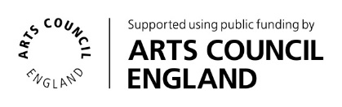
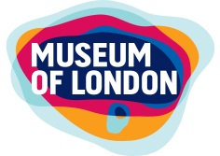
@LondonMusDev

