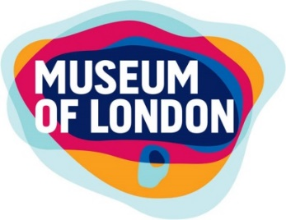Goody bag order sheet

Museum of London goody bags are a quick and easy alternative to visiting the shop. They contain 4 items each and provide a saving of 75p per bag than buying the items separately.

This form can be emailed in advance of your visit to shop@museumoflondon.org.uk

Alternatively, please hand this form in to a member of the shop team at the start of your visit.

Your order will be ready for collection and payment at the end of your museum visit. Payment is accepted in cash, card or by school cheque.

Your name:

School name:

Date of visit:

Collection time (this can be confirmed on the day):

MoL Goody bag  £3.00 each |  | £
Roman Numeral Goody bag  £3.00 each |  | £

Museum of London Goody bags come in individually packed bags to make for easy distribution for teachers. They contain practical but fun stationery.
Every purchase helps support the work of Museum of London

Museum of London Goody bag contains:

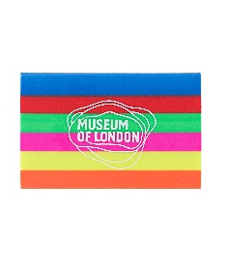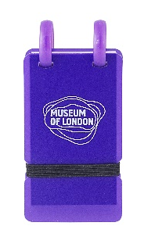

Museum of London branded pen, pencil, book shaped eraser and mini notepad – combined price of £3.00

Roman Numeral Goody bag contains:

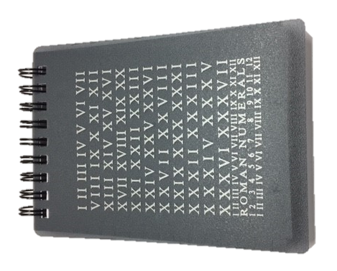

Roman Numeral branded pencil, book shaped eraser and small notepad – combined price of £3.50

Other goody bag options:

We can tailor make smaller or larger goody bags upon request. Email shop@museumoflondon.org.uk or call 020 7814 5600 for further detail.

Visiting the main shop:

It is advisable to notify the shop upon your arrival at the Museum of you intended visit time. This allows us to plan crowd flow in the shop for your ease.

Every purchase helps support the work of Museum of London

